Practical 3
Open both the CSV files.
Then drag the 2nd csv file besides the first one and make Relation between the files.
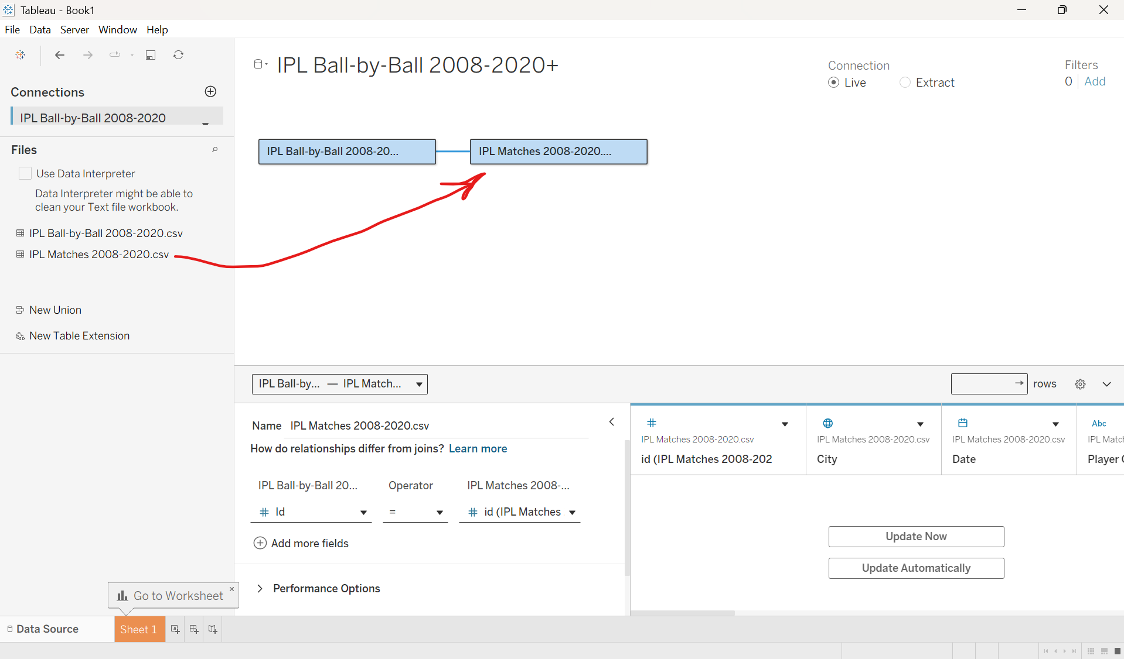
1)Title Winner worksheet
Take new worksheet and name it as “Title Winner”.
Drag “winner” and “Date” in row.
Right click on date and select “Exact date” and “Discrete”.
Again drag another date in row.
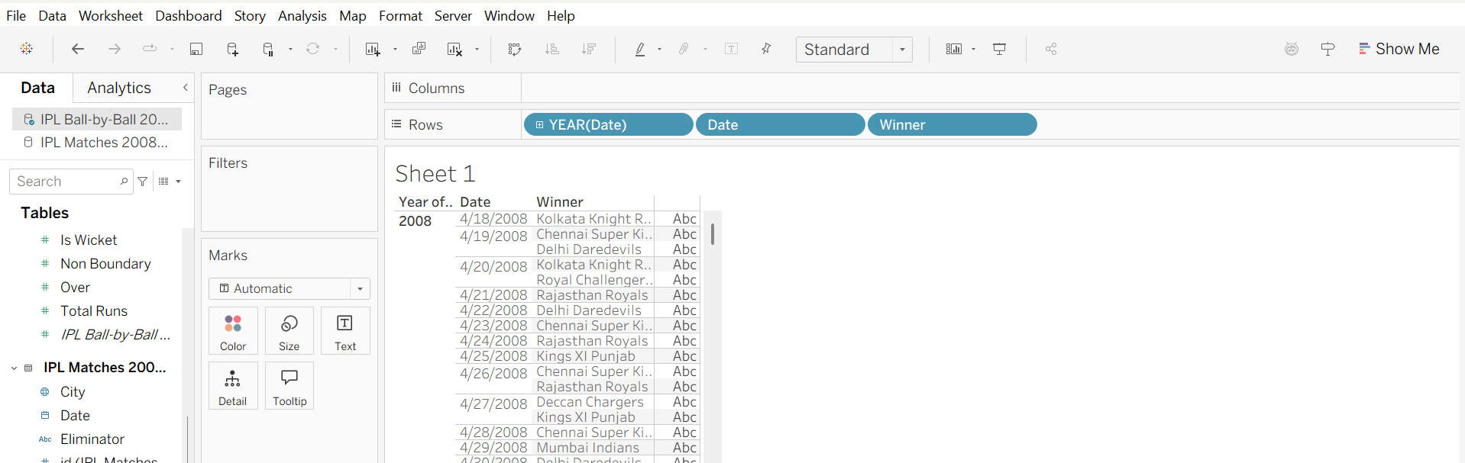
Now we will create Calculated field:
Go to analysis->create calculated field-> give the name and write the formula -> apply and ok
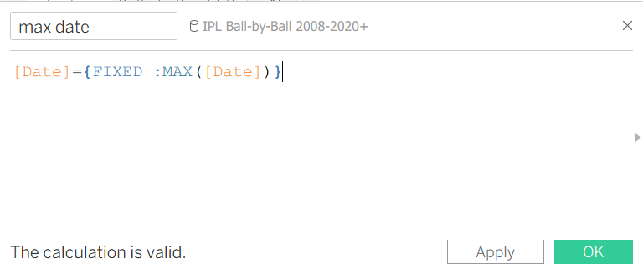
Drag and drop Calculated field(max date) in filters ->select TRUE->Apply and OK
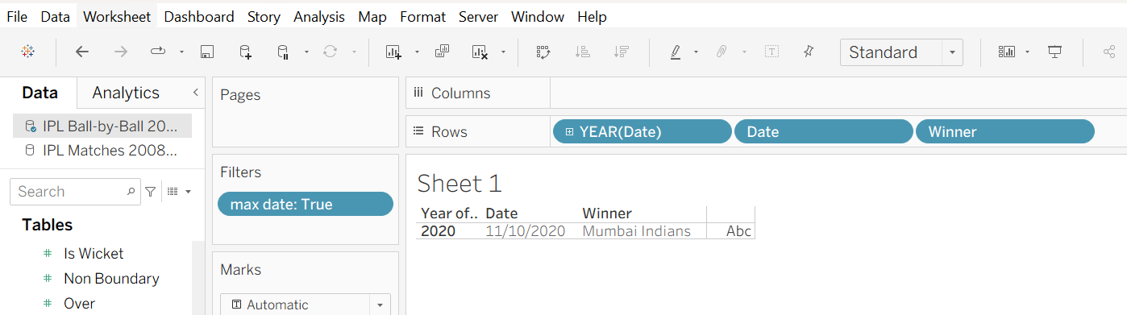
Drag and drop date in filters Next select All Apply and Ok
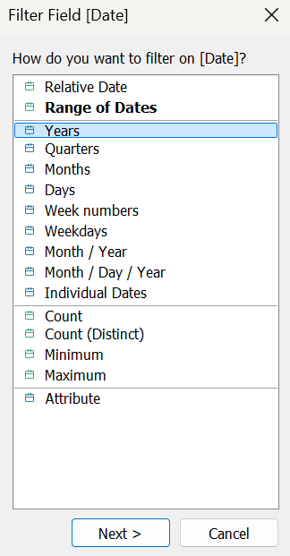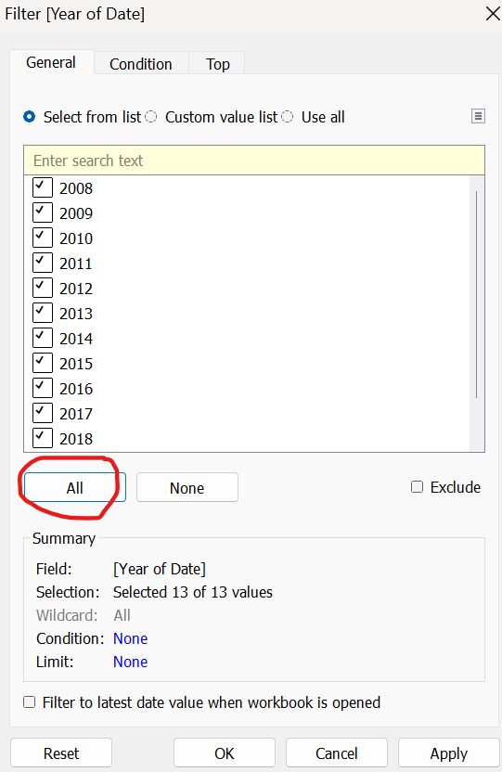

Drag date in filters->right click onn it->Add to context-> again right click on it ->show filters.
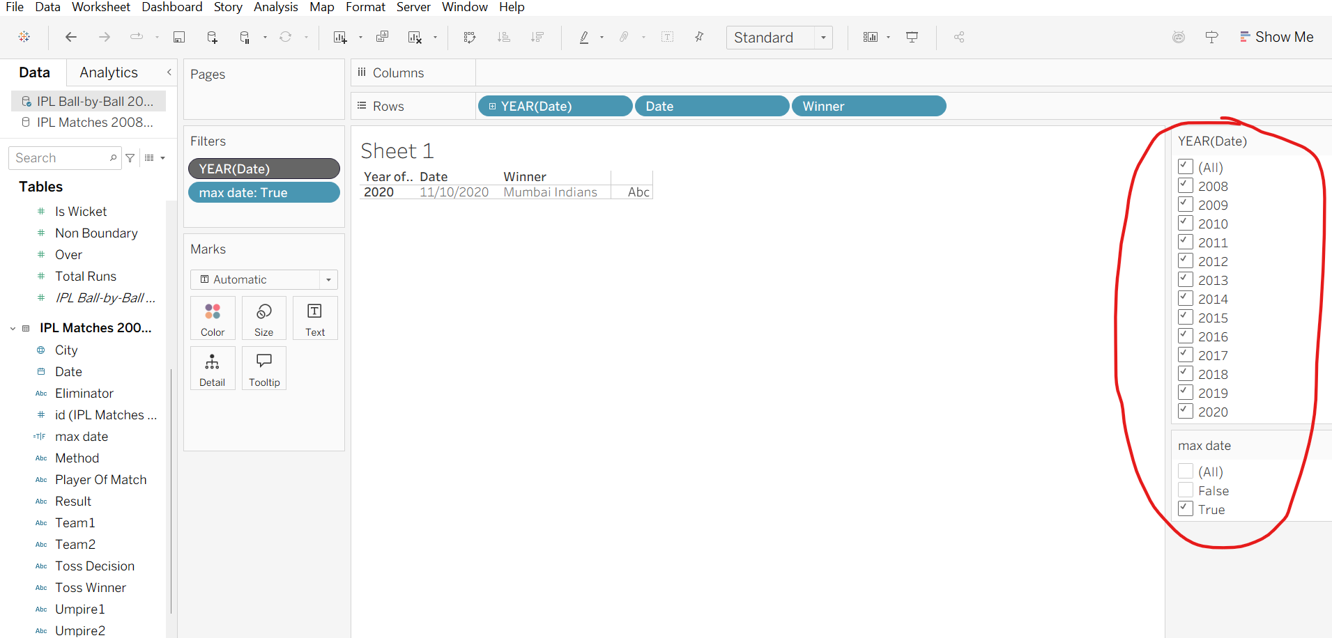
Remove all the fields from rows and drag and drop the Winner column in the test labels in the marks. Keep it on Entire View. Click on labels 3 dots Format the title font bold etc.
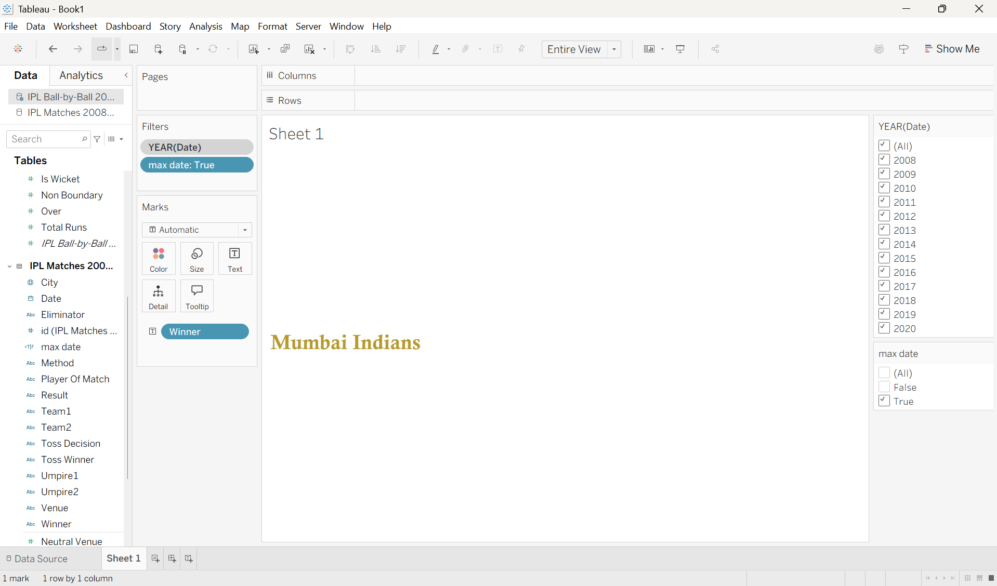

Right click on the Date column Apply to Worksheets All Using This Data Source.
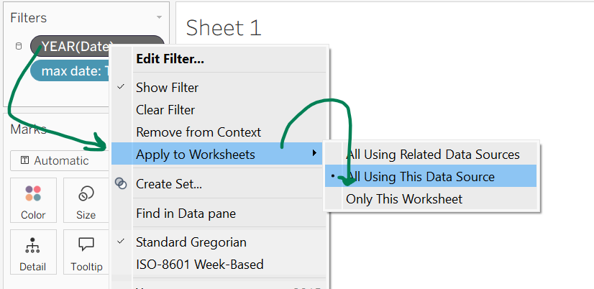
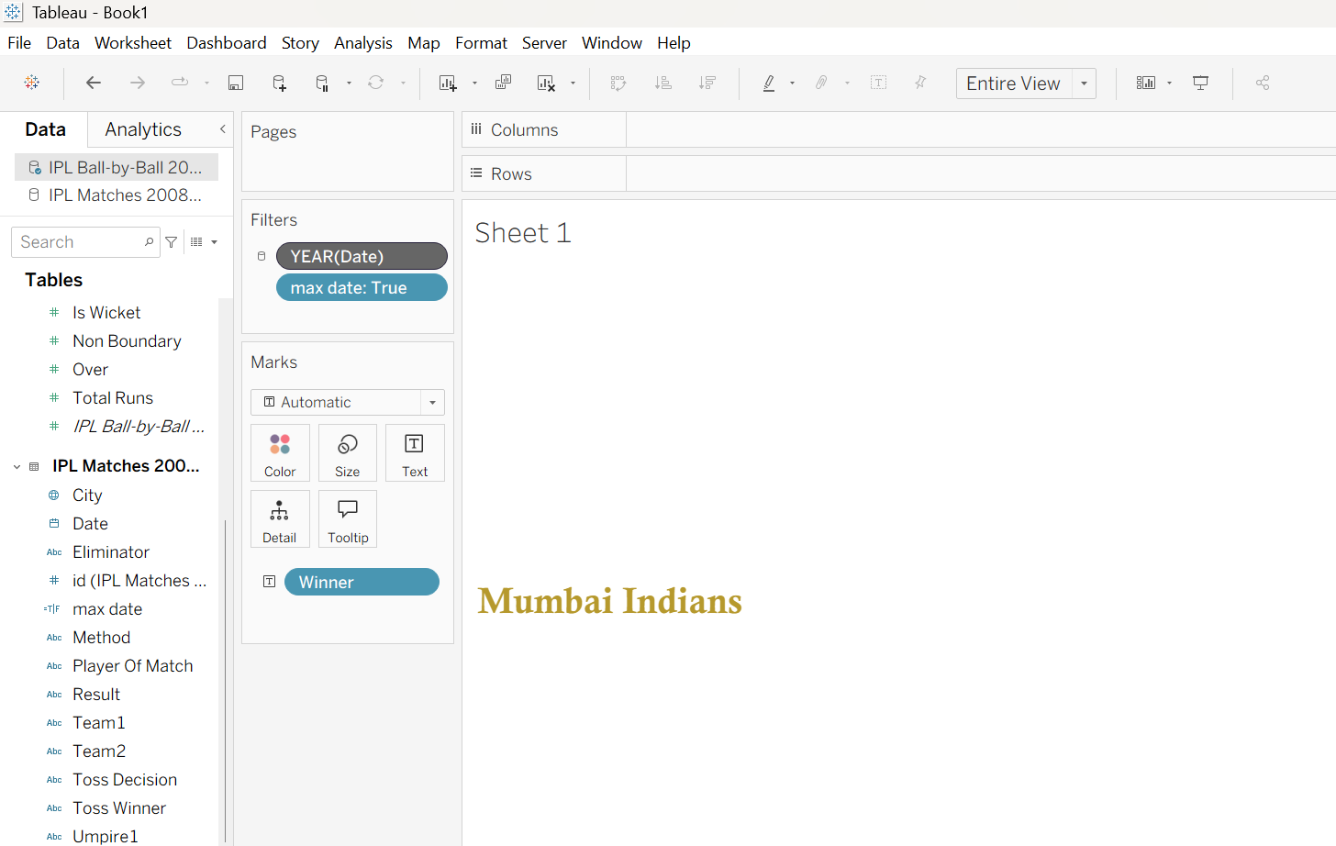

2)Orange cap worksheet
Take new sheet.
Drag and Drop ‘Batsman’ columns in Row and ‘Batsman Runs’ column in Text.
Press Ctrl key on keyboard and Drag and Drop Batsman column from rows into Filters.
In Filters Right Click on Batsman Click on Edit Filter Go to Top Menu and Select ‘By Field’ Set it to 1 instead of 10. Apply Ok.
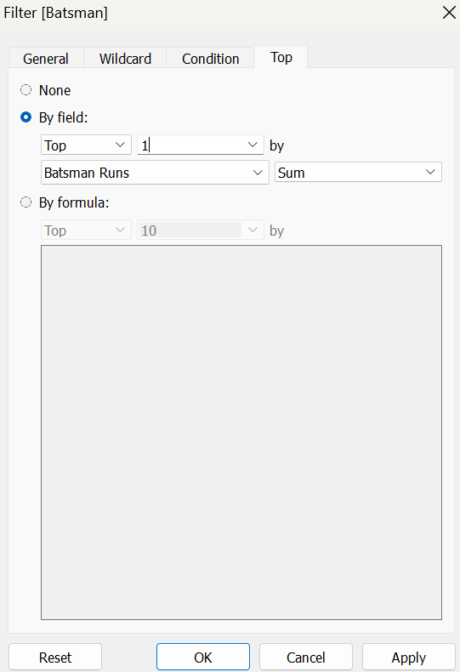
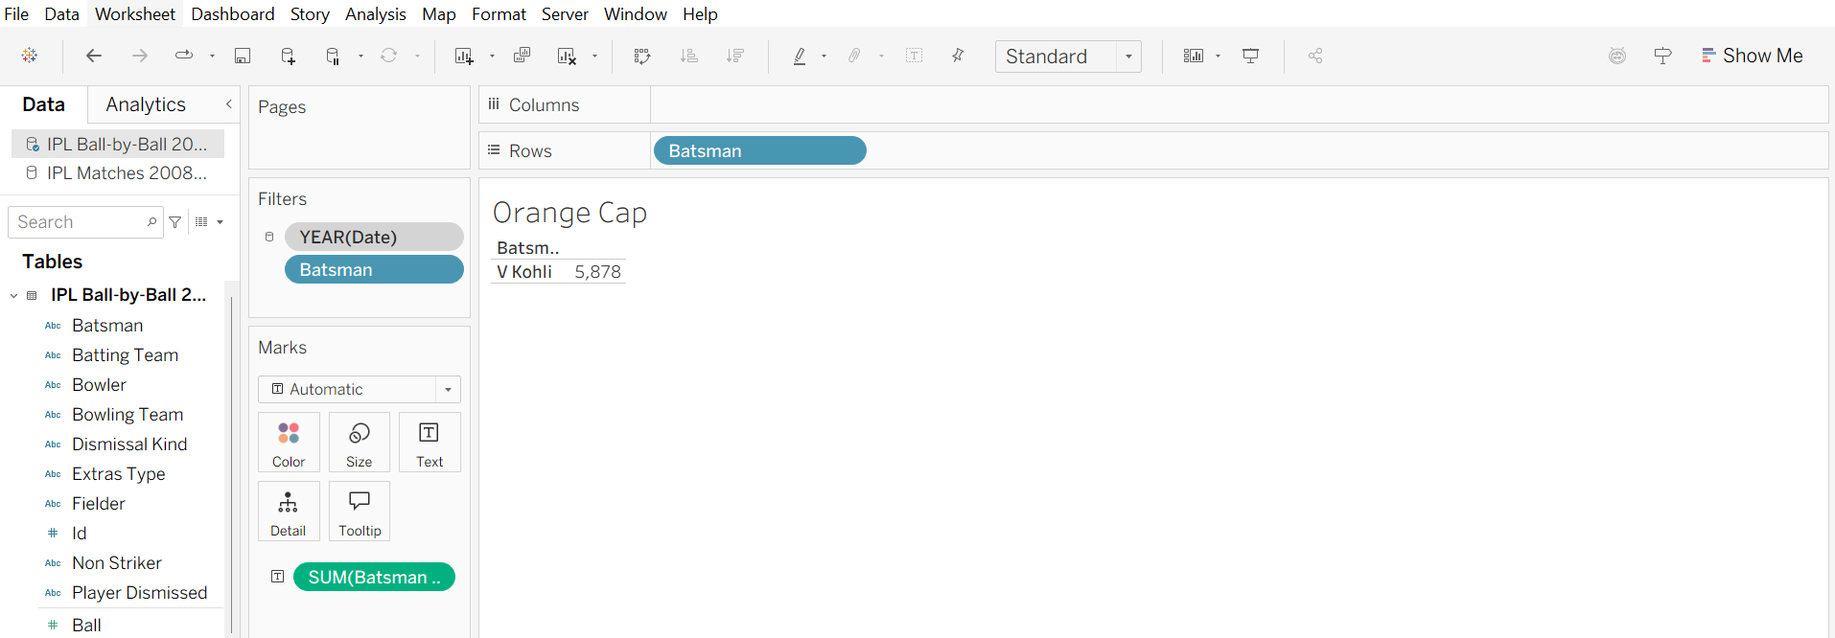
Drag and Drop Batsman column from rows to Text 3 Dots give some Formatting.
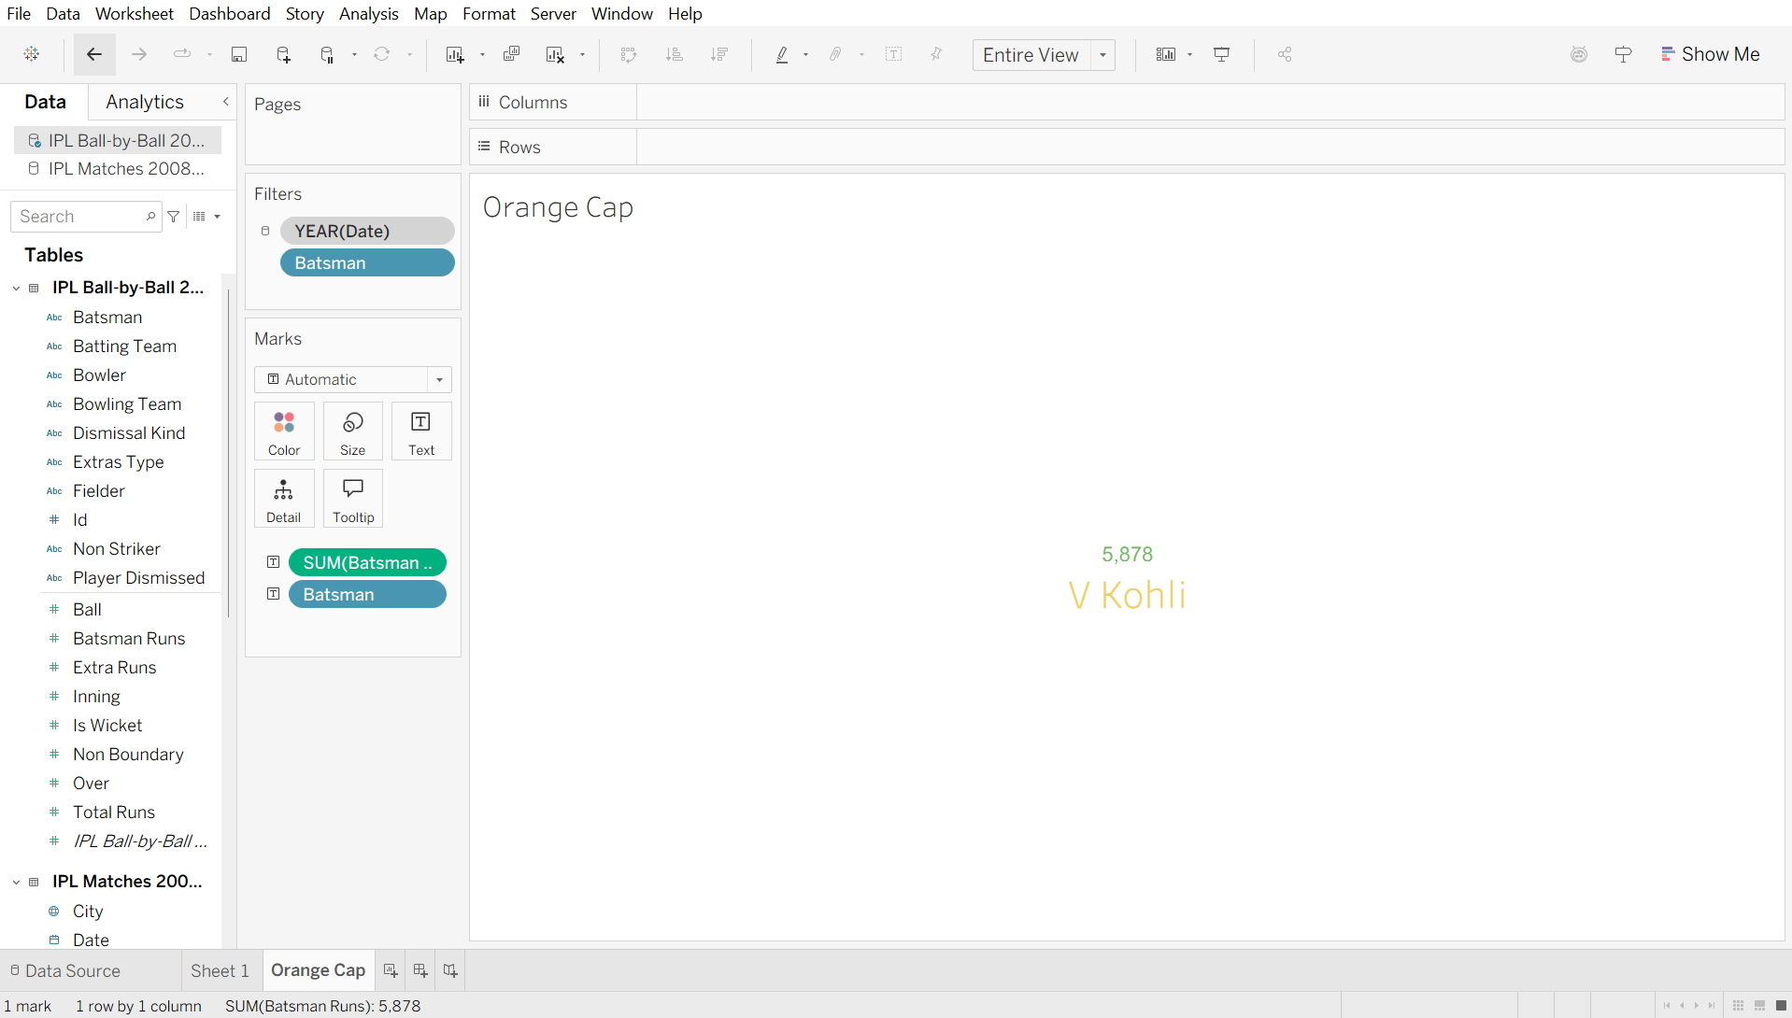

3)Purple Cap Worksheet
Drag and Drop ‘Dismissal Kind’ column in Filters Select the required columns and shown in the below image. Apply Ok. (also tick the ‘run out’, as it’s not shown in the below image).
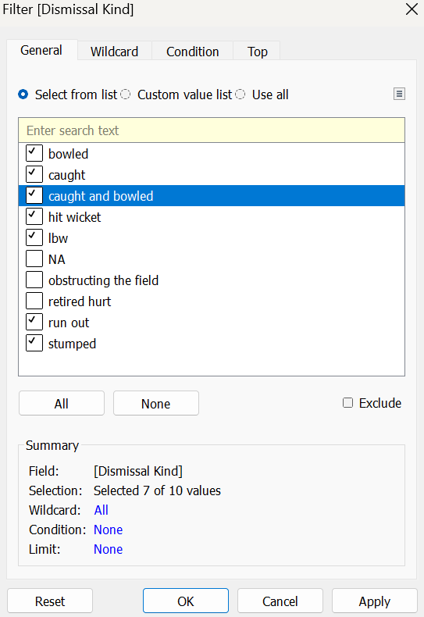
In Filters, right click on the Year and select ‘Show Filter’ In year, in dropdown select ‘single value (dropdown)’.
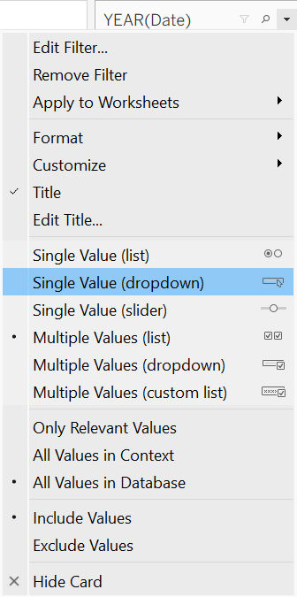
Drag and drop ‘Bowler’ column in rows and ‘Is Wicket’ column in Text under Marks.
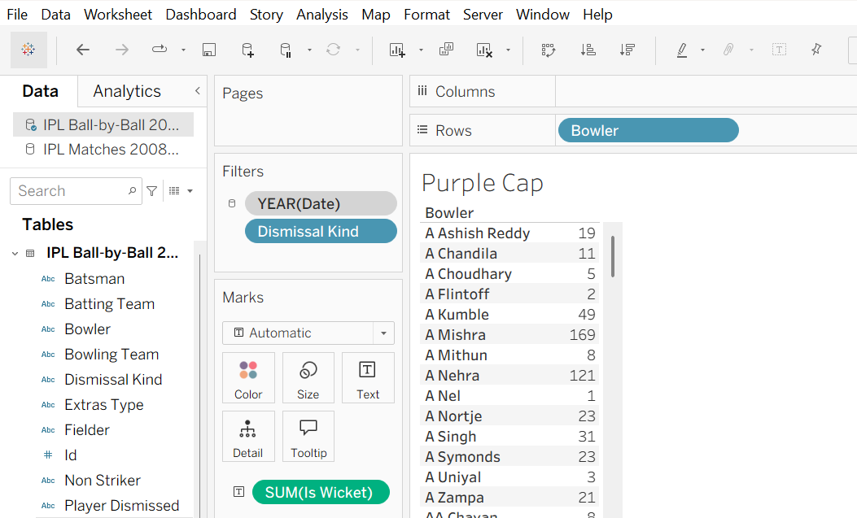
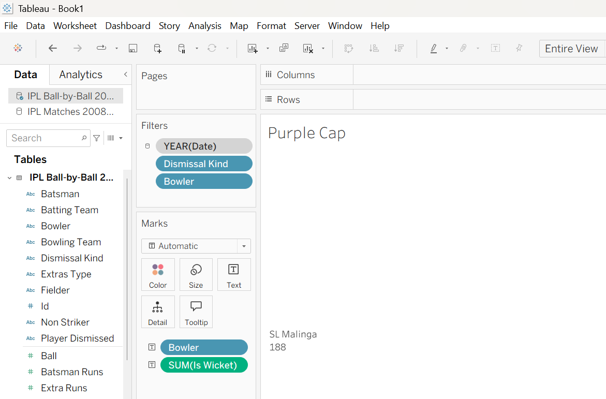

4)Tournament 6 worksheet
Drag and drop Date column in Filters, click the ‘Years’ Next.
Drag and drop ‘Batsman Runs’ in Filters Select ‘All Values’ Next Give a range of 6 to 6 Apply Ok.

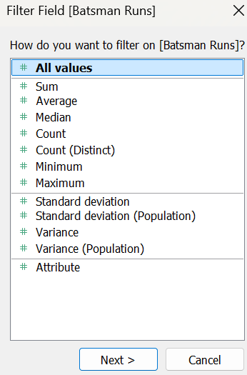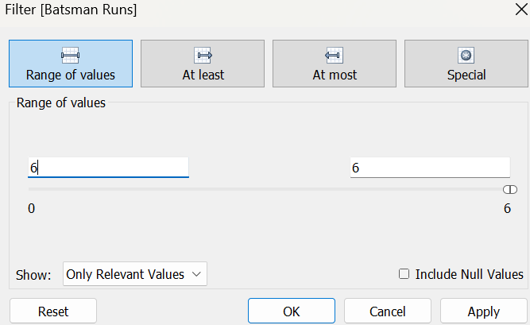
Drag and drop Batsman Runs in Text. Right click and Format.
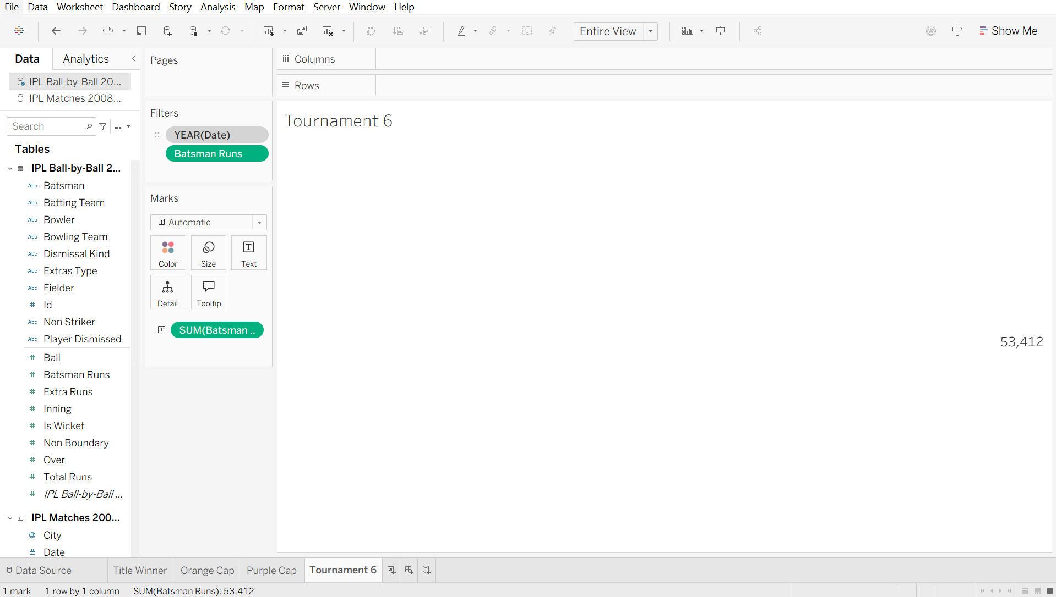

5)Tournament 4 worksheet
Drag and drop Date column in Filters, click the ‘Years’ Next.
Drag and drop ‘Batsman Runs’ in Filters Select ‘All Values’ Next Give a range of 4 to 4 Apply Ok.
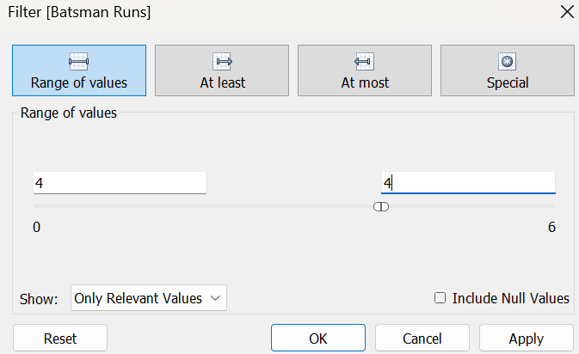
Drag and drop Batsman Runs in Text. Select ‘count’ in Measures Right click and Format.
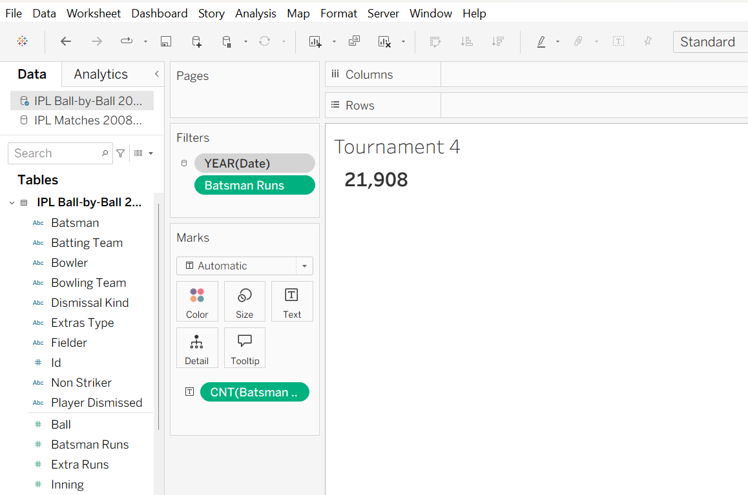

6)Team Image Worksheet
Dublicate “title image”
and remane as team image
In marks select shape
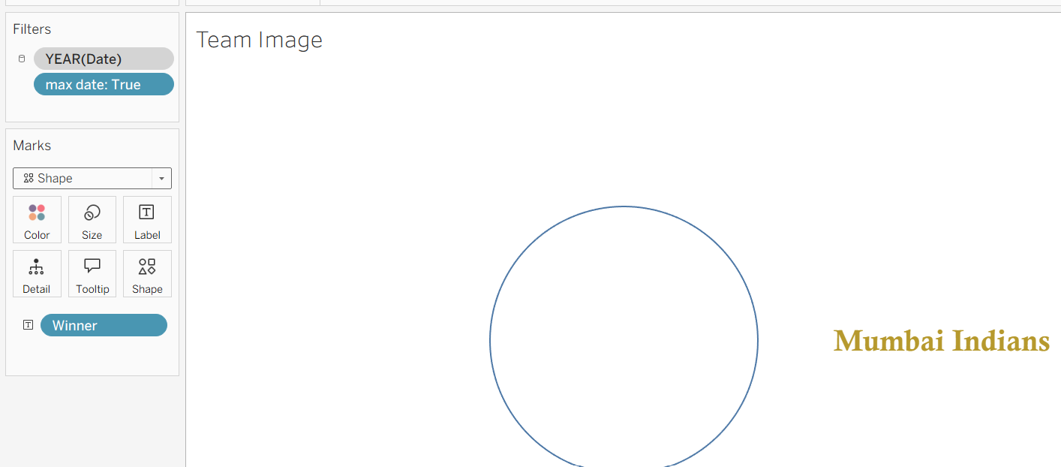
and then drag winner in shape button.
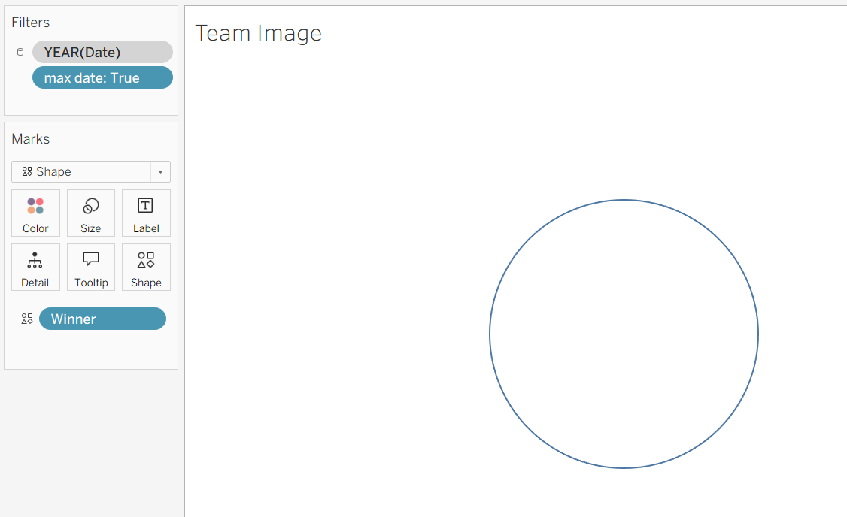

Then go to documents and in tableu file(The Tableau Repository) shape make a folder team add all images in it.
Then click on shape button->selexct the namein side dropdown->reloadit-> we will see the team folder in dropdownselect the img and apply and ok
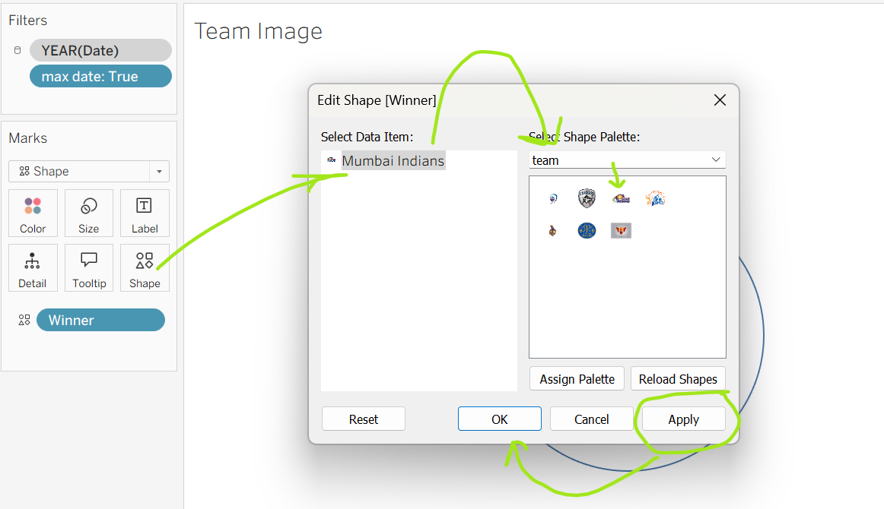
Same way assign for all the teams
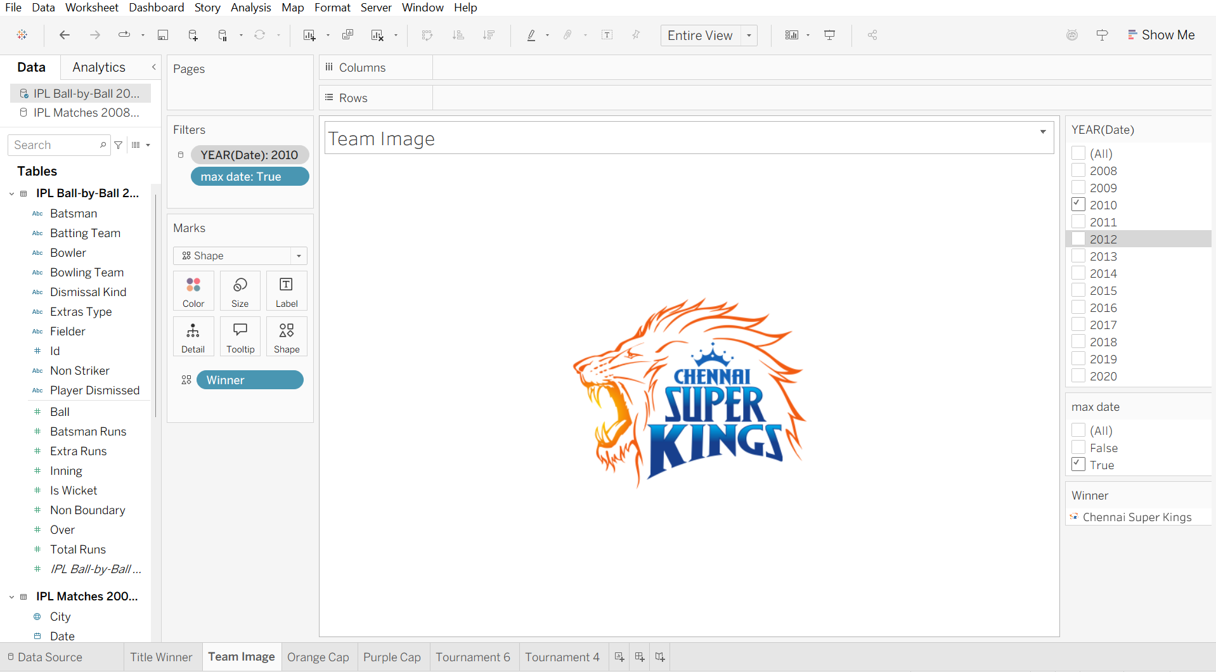

6)Match win based on Toss decision worksheet
In side table->right click on winner->create->group-> select delhi(both) and select group.-> same way for pune.
then apply and ok.
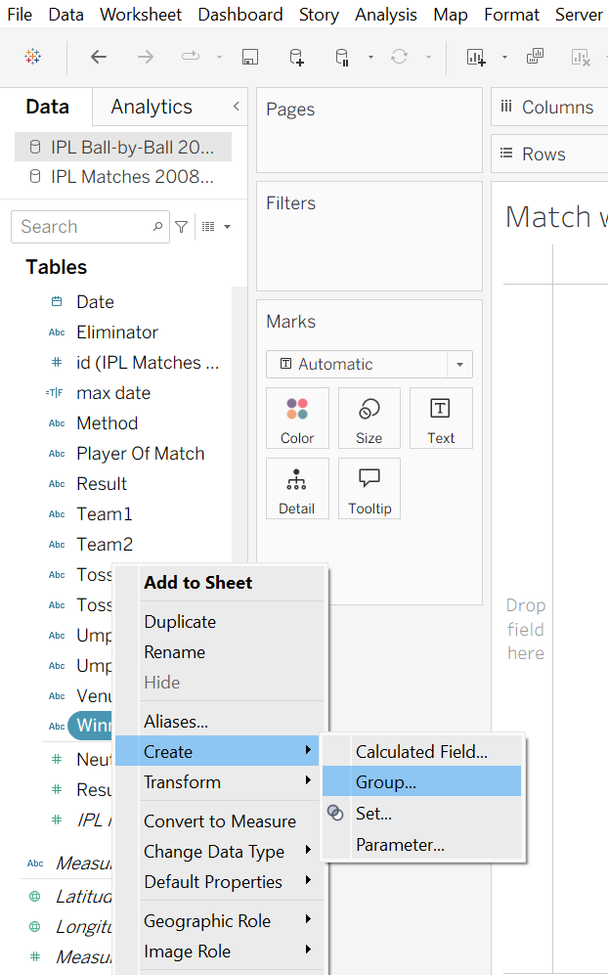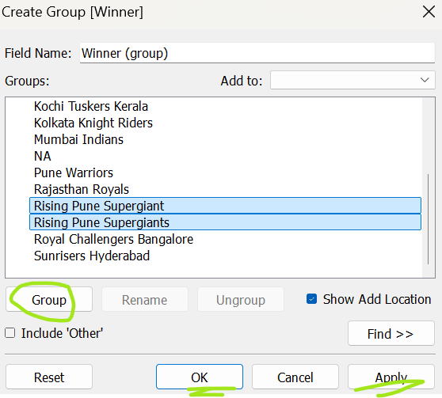
now winner(group) will be created.
drag winner(group) in row.
drag winner in columns-> select count measure.
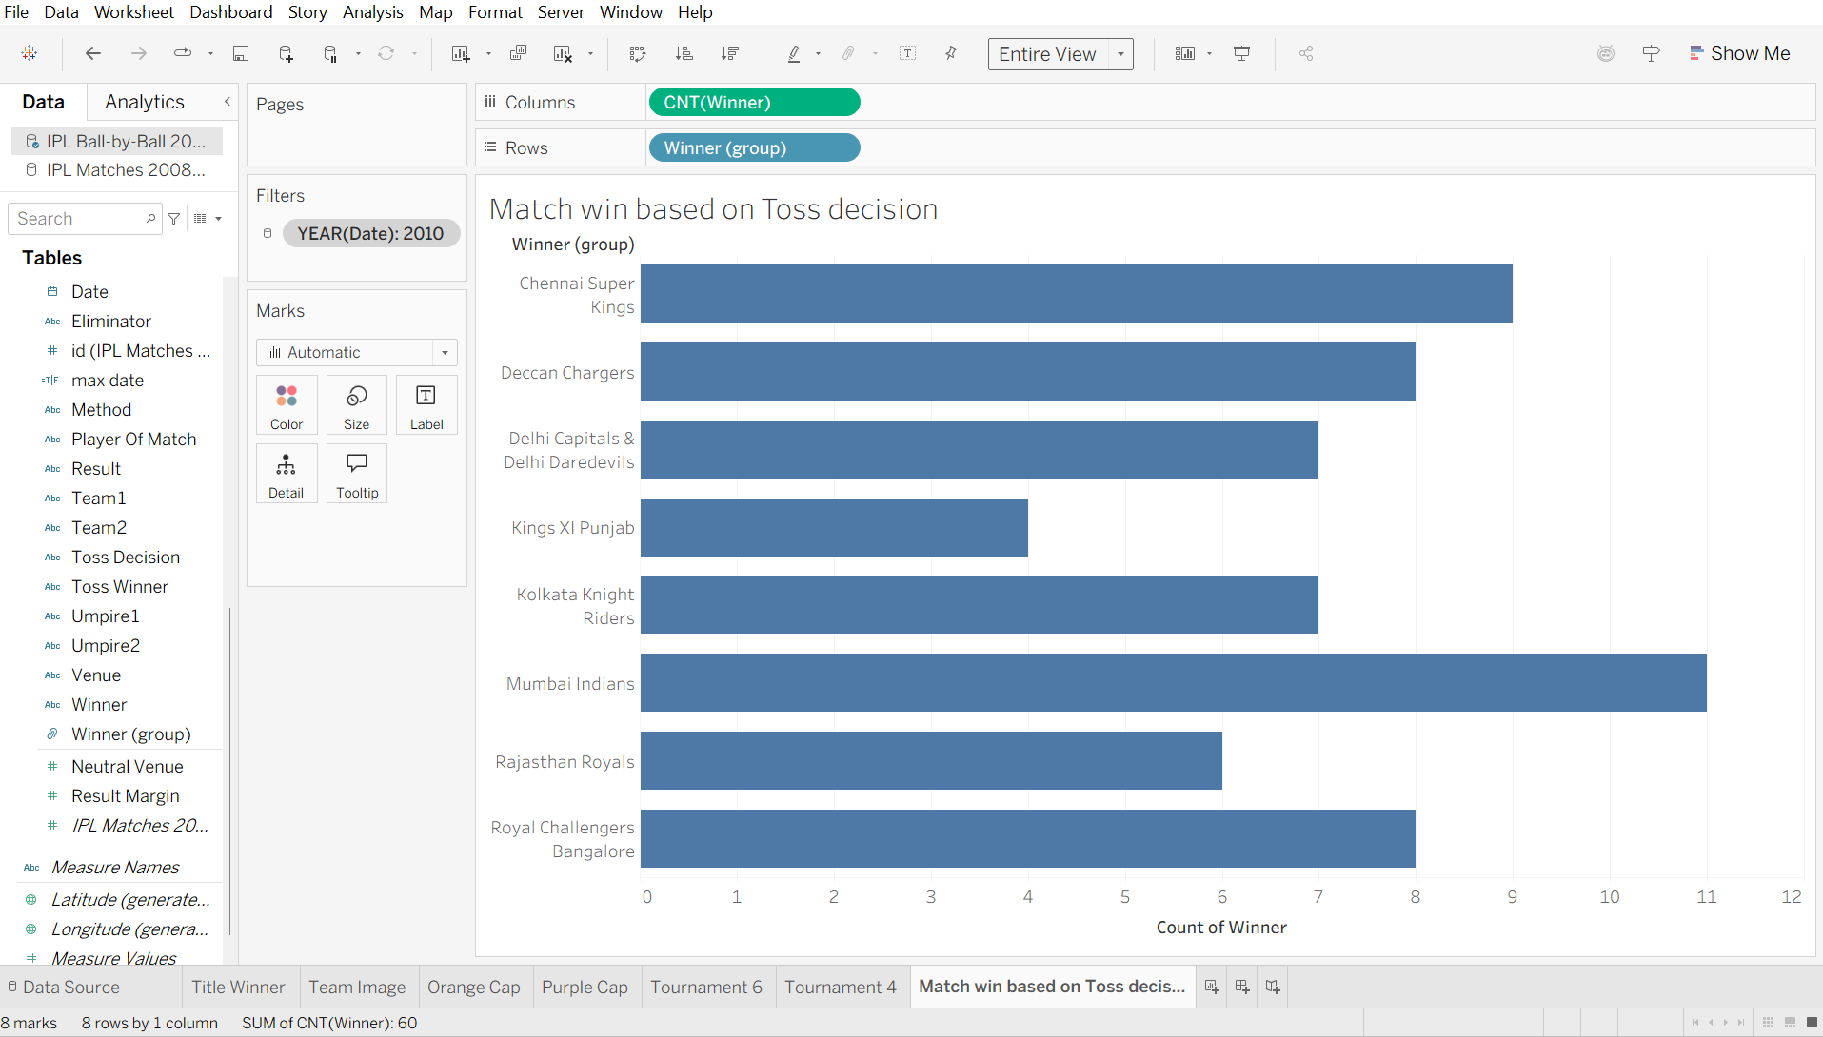
drag trossdecicion in color button
now in the above tab where we click “entire fit” besides that there is [T] button-> click on it-> now we will see labels in bars
if we want to edit the x and y axix-> right click on it->format
now in x axix -> wnt to delete-> count of view-> right click->edit axis-> just erase the.-> apply ok
to choose the color of bars-> click color button->edit color-> choose of our own.
to change worksheet colot->right click-> format-> worksheet-> choose color
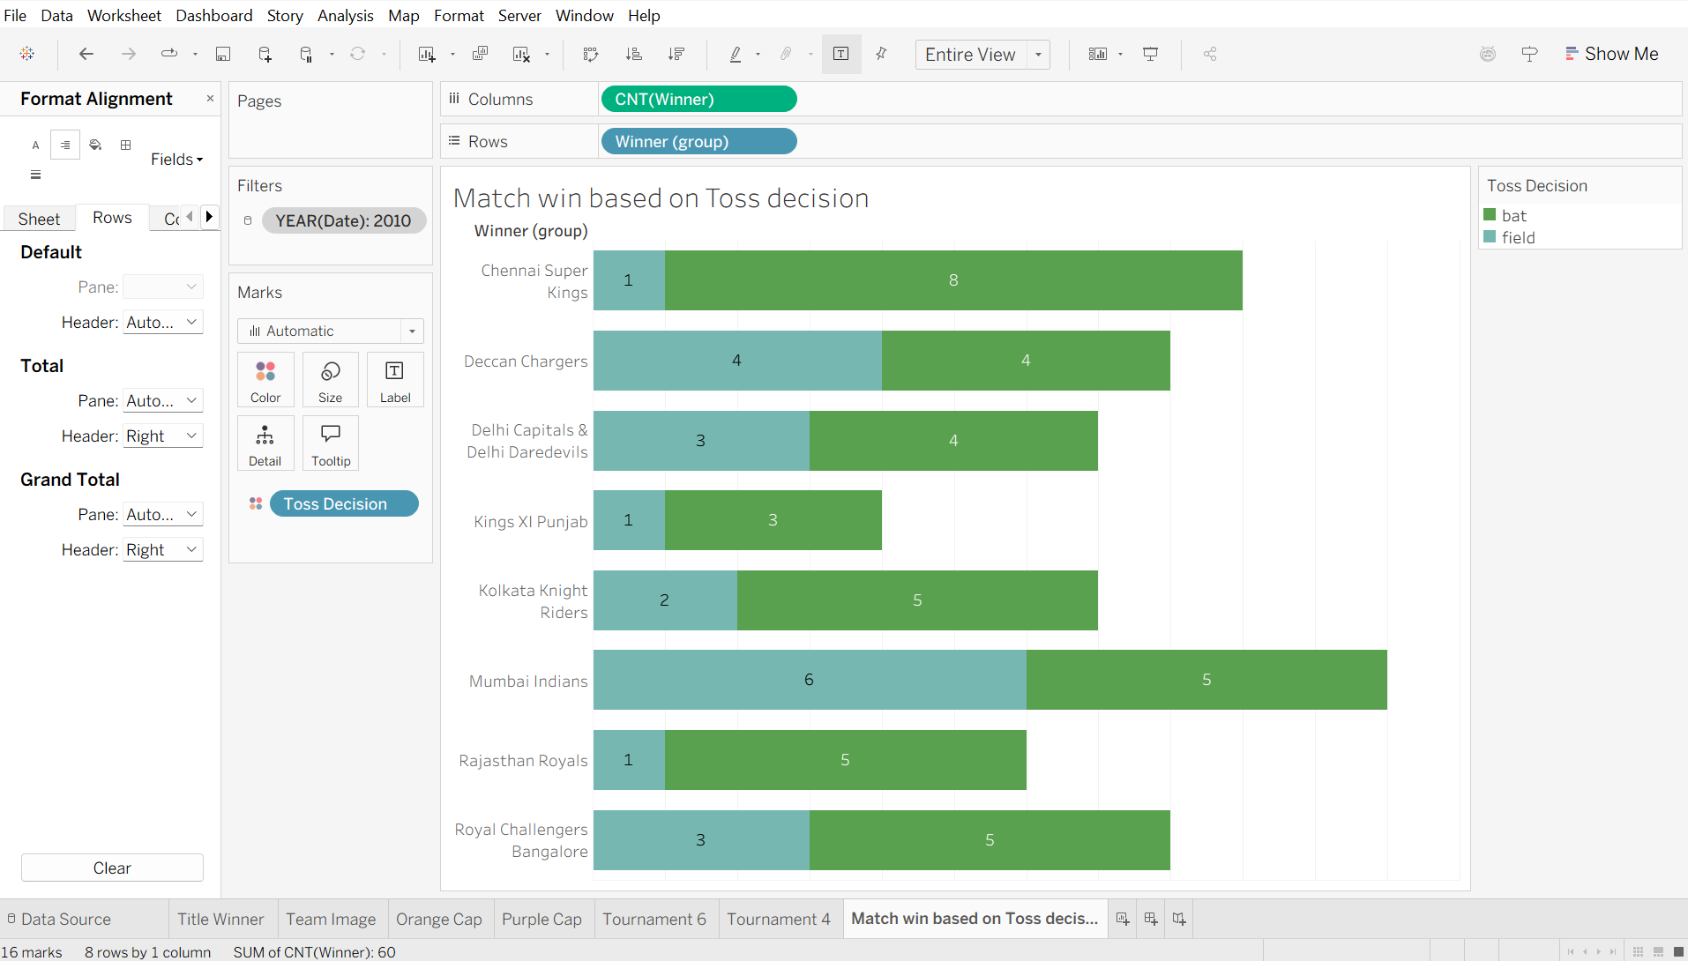
7)Donut Chart Worksheet
drag winner in text button
sekect pie
drag toss decision in color and label.
convert winner label in count
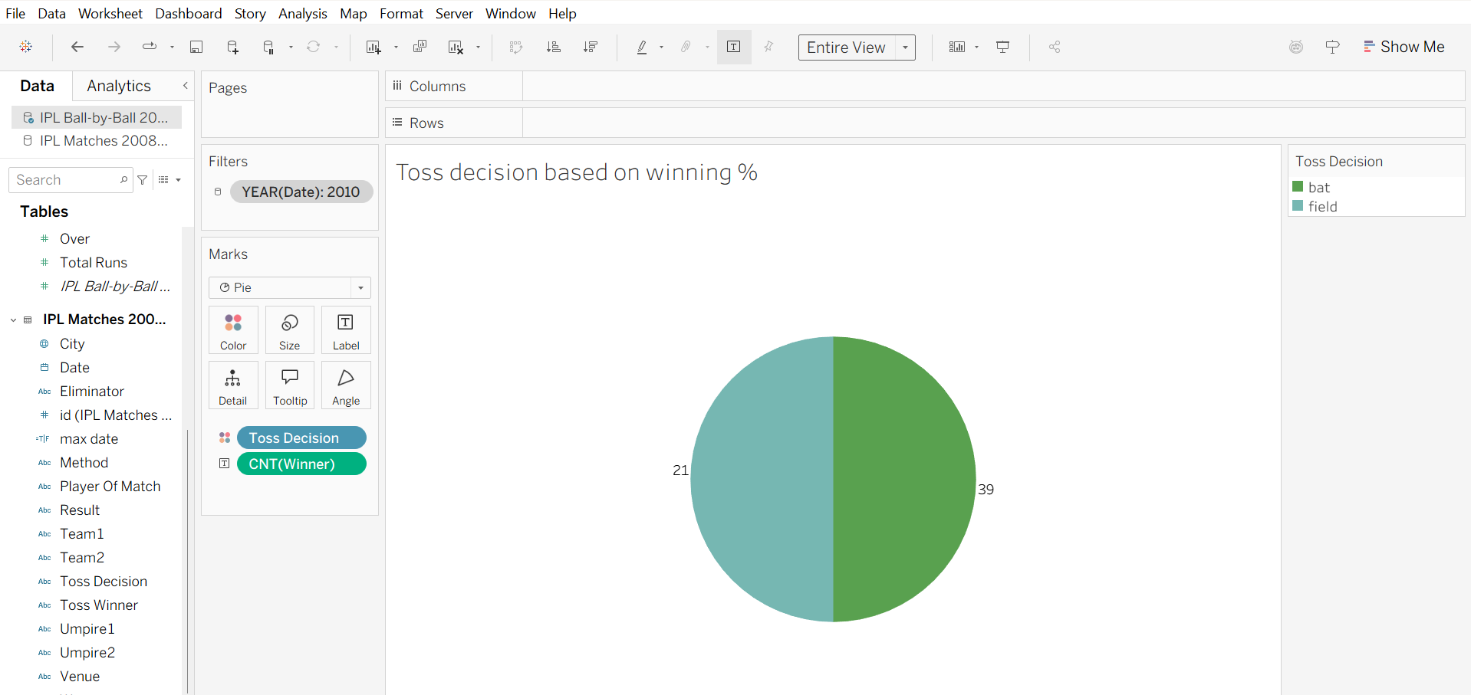
now press ctrl button and drag count winner in angle.
now to calculate %age->right click cnt winner of T->Quick table of calc-> percent of total
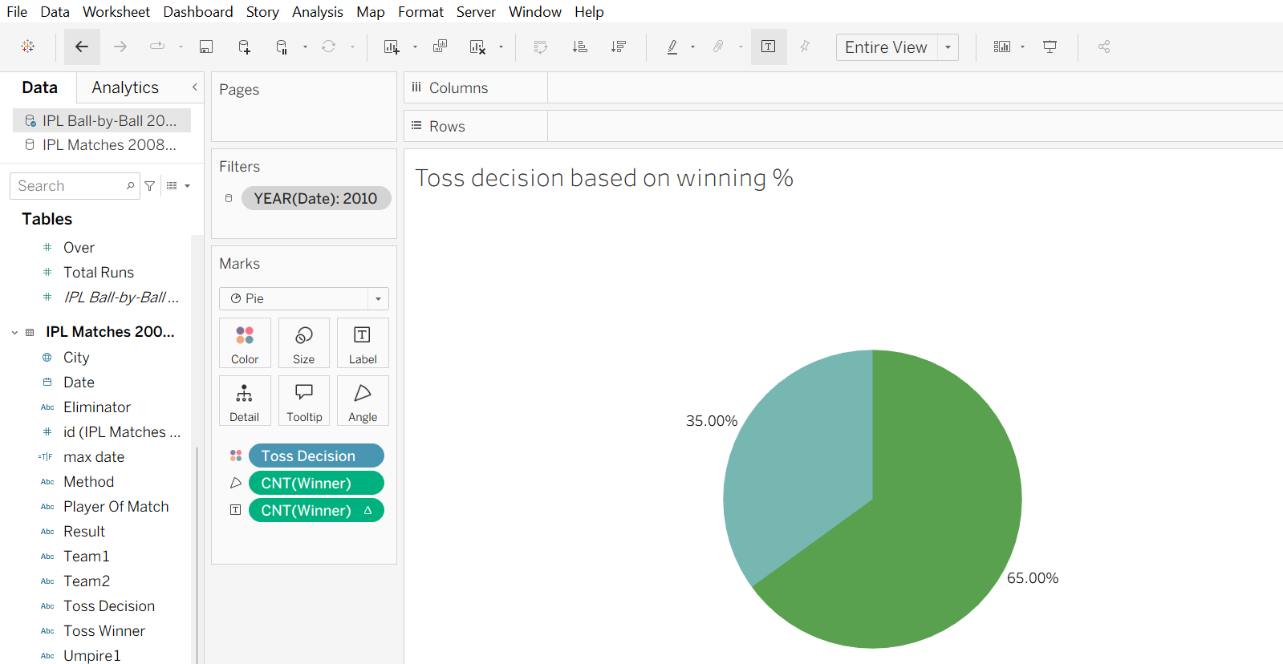
NOW IN col-> double click-> type-AVG(0)-> then press ctrl and dublicate it in col only->
now we will get 2 pie charts.
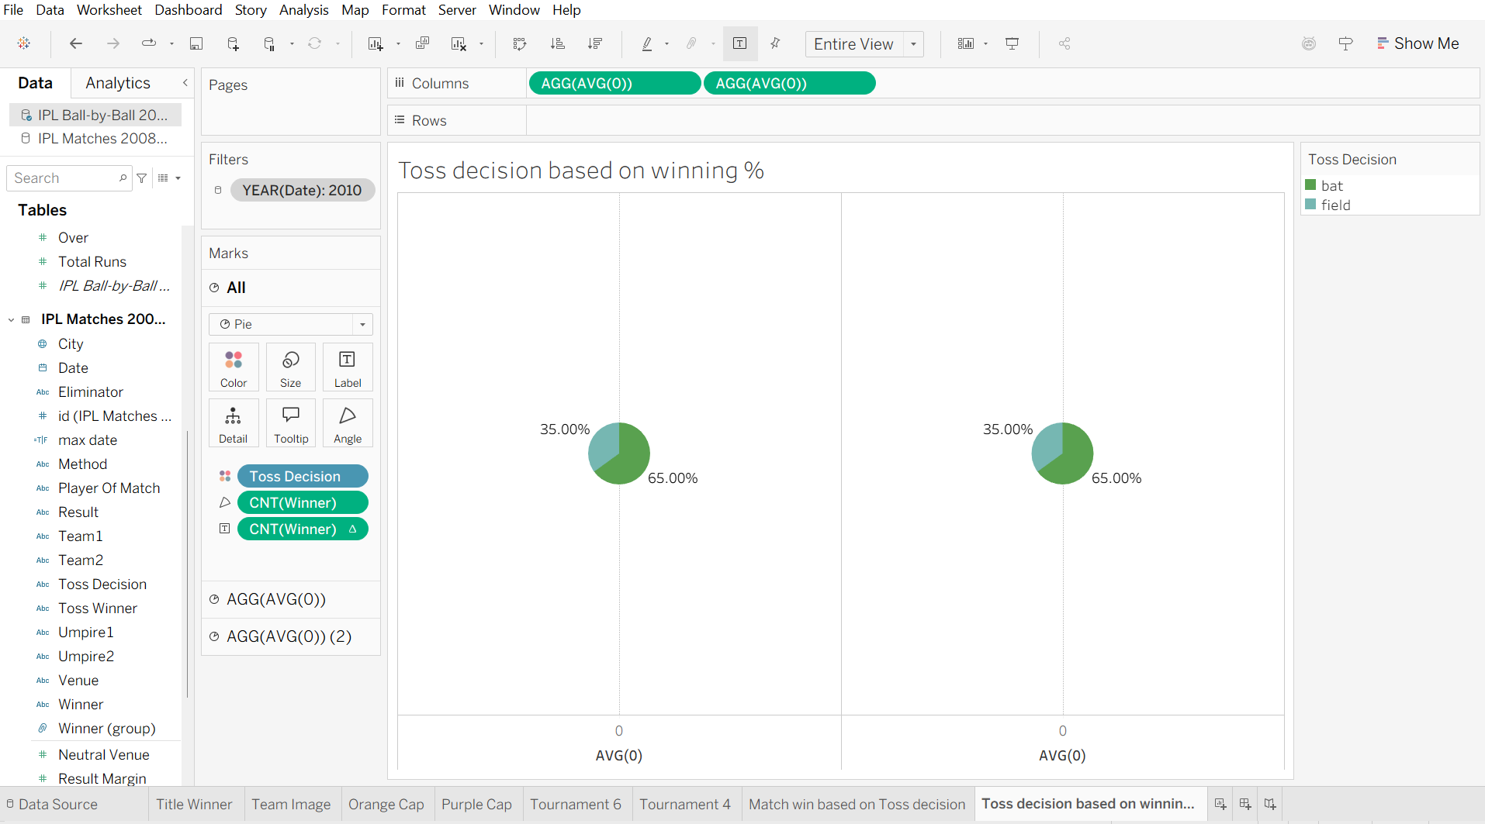
now in marks- we will se 2 aggg-> remove everything from the second mark right click the 2nd agg -> dual axis->now both we look overlapped-> to make it like donut chart-> click 1st agg-> and increase the size.
now change the color of inside circle->remove axis and lines-> click on grid->make everything none.
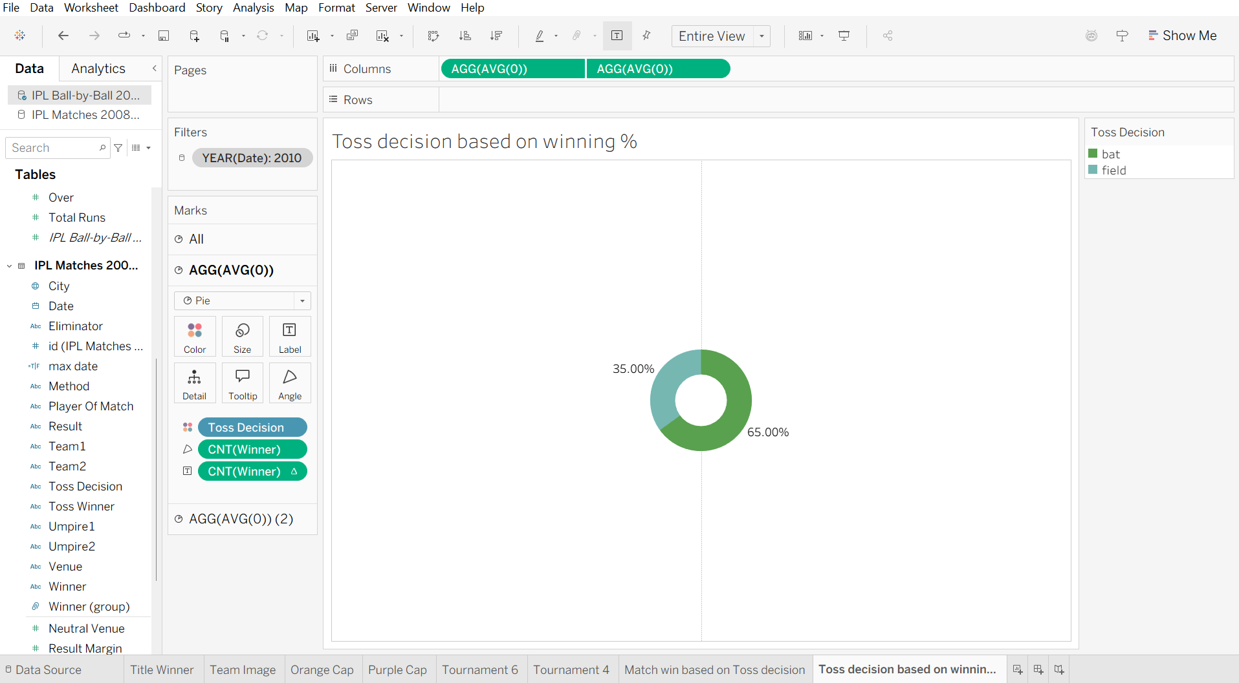
to add tooltip-> select the first agg->tooltip->and remove unnecessary once and add matches won based on toss decision.
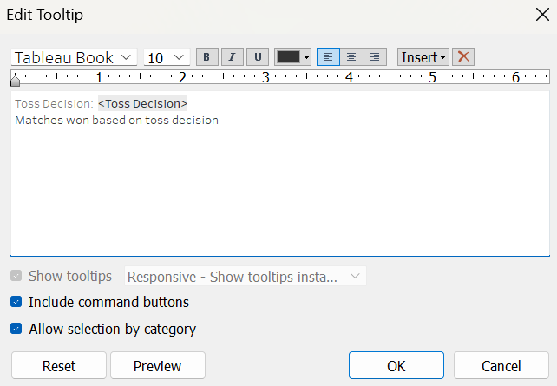

8)Orange cap worksheet 2
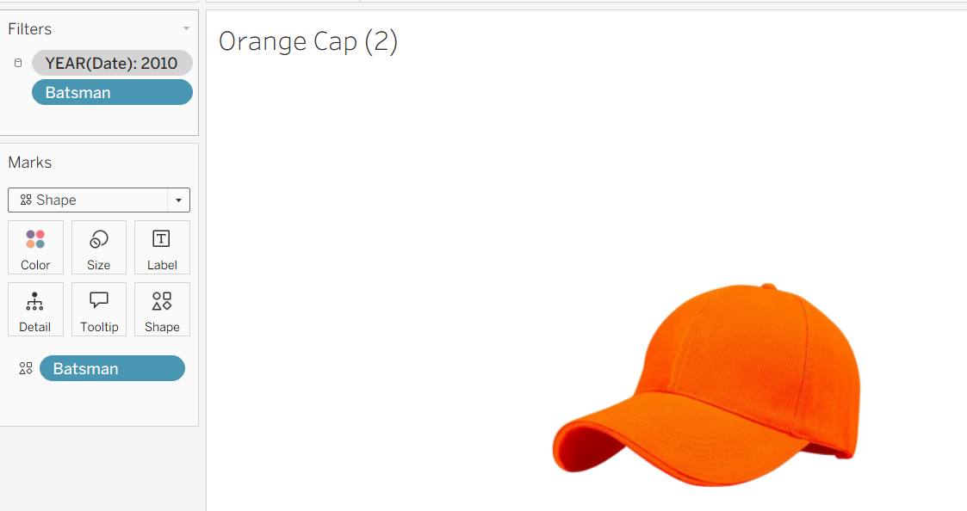
&
9)purple cap worksheet 2
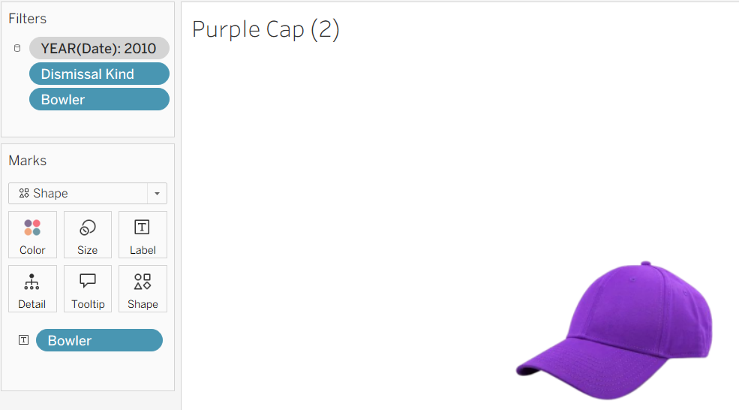
Dashboard Creation
now create container in it->select tiled-> double click horizontak-> drag verticle and black in it.
now drag title winner, orange cap and purple cap in the first box
And remaining in the blank one.
